### COS30015 IT Security

You will need:

File task1.txt on Canvas

Lab Computer

### Lab 9 week 9

In this lab, you will engage in email forensics as your primary task. You will explore fundamental concepts such as agents, protocols, and authentication, and analyse an email formatted in MIME. This foundational knowledge will enhance your understanding of email forensics analysis. Afterward, you will be required to answer some related questions to reinforce your understanding.

### Task 1 Understanding the Process of Sending and Receiving Emails

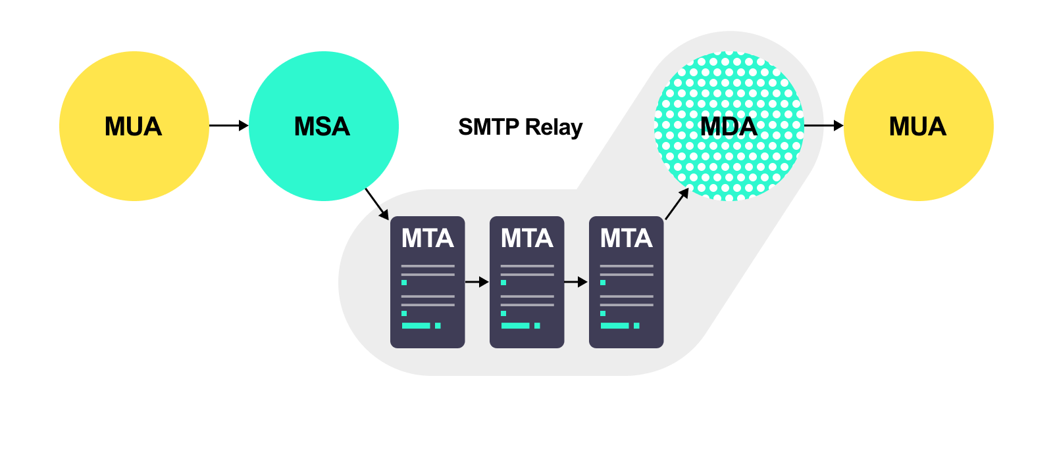

Figure 1 Process of Sending and Receiving Emails

### 1.1 Agent

In email transmission, an agent refers to specific software components responsible for handling and managing emails during the processes of sending, transferring, and receiving. This includes MUA, MSA, MTA, and MDA.

1. **MUA**
   * **Concept**: MUA stands for Mail User Agent, which is a software application that enables users to send, receive, and organize email messages. Essentially, it acts as the client-side component in the email architecture, interfacing directly with end-users.
   * **Key Functions**: Composing Email; Sending Email; Receiving Email; Email Organization; Address Book Management:
2. **MSA**
   * **Concept**: MSA stands for Mail Submission Agent, which is a software application responsible for receiving outgoing email messages from the Mail User Agent (MUA) and ensuring their proper submission to the Mail Transfer Agent (MTA) for further delivery. It acts as the intermediary between the MUA and MTA in the email architecture.
   * **Key Functions:** Receiving Emails; Authentication and Authorization; Email Formatting and Compliance; Error Handling; Communication with MTA;
3. **MTA**
   * **Concept**: MTA stands for Mail Transfer Agent, which is a software application that transfers email messages from one computer to another using the Simple Mail Transfer Protocol (SMTP). The MTA acts as the middleman between Mail User Agents (MUAs) and Mail Delivery Agents (MDAs) within the email delivery process.
   * **Key Functions** Routing; Relaying; Queue Management; Policy Enforcement; Reporting:
4. **MDA**
   * **Concept**: MDA stands for Mail Delivery Agent, a software application responsible for receiving email messages from the Mail Transfer Agent (MTA) and delivering them to the recipient's mailbox. It acts as the final step in the email delivery process, ensuring that emails reach their intended destination on the server or the user's local machine.

### 1.2 Protocol

In the process of email transmission, discussing key communication protocols is crucial because these protocols ensure the secure, accurate, and efficient delivery of emails from sender to recipient. Understanding how these protocols collaborate can help us design and maintain stable email systems and address common issues during transmission. Please consider the following protocols: their functions, application scenarios, and Ports:

1. **SMTP (Simple Mail Transfer Protocol)**
2. **POP3 (Post Office Protocol, Version 3)**
3. **IMAP (Internet Message Access Protocol)**
4. **ESMTP (Extended Simple Mail Transfer Protocol)**

### 1.3 Digital Signature

Digital Signature is an electronic signature based on cryptographic techniques used to verify the identity of the sender of a message or file and ensure that its content has not been tampered with during transmission. It is generated using the sender's private key, and the recipient uses the public key to verify the authenticity of the signature and the integrity of the data.

***



***Think about what a PGP (Pretty Good Privacy) is and how it works***

### 1.4 MIME (Multipurpose Internet Mail Extensions)

MIME (Multipurpose Internet Mail Extensions) is an internet standard that extends the functionality of email, enabling it to transmit multimedia content beyond plain text, such as images, audio, video, file attachments, and text in different character encodings. MIME adds formatting rules to email, allowing complex files and content to be transmitted via email.

### 1.5 Email Authentication Standards

### 1.5.1 SPF (Sender Policy Framework)

SPF is an email authentication mechanism used to prevent sender address forgery. It allows domain owners to specify which servers are authorized to send emails on behalf of their domain.

How SPF Works

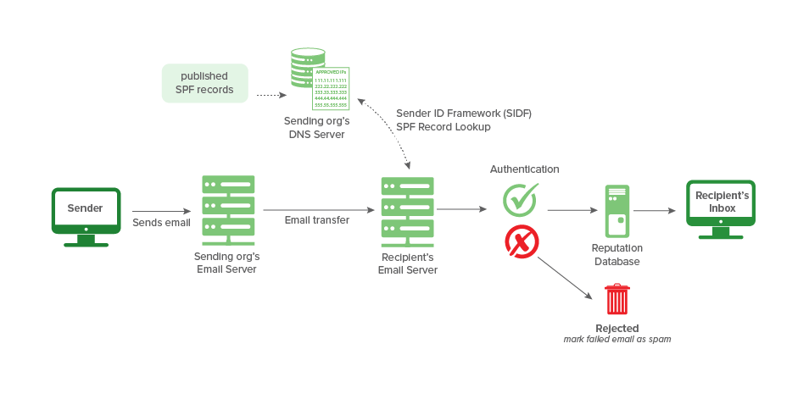

### 1.5.2 DKIM (DomainKeys Identified Mail)

DKIM (DomainKeys Identified Mail) is an email authentication protocol that generates a digital signature to verify the identity of an email sender. Mail providers check the DKIM signature in the email header against records published in the sender's domain name system (DNS). This process uses an encrypted key to help detect forged sender addresses. Major email providers, such as Google, Apple Mail, and Outlook, rely on DKIM signatures when authenticating emails.

***



* ***Consider how the hash function is used in this scenario.***
* ***What is its role?***

How DKIM Works

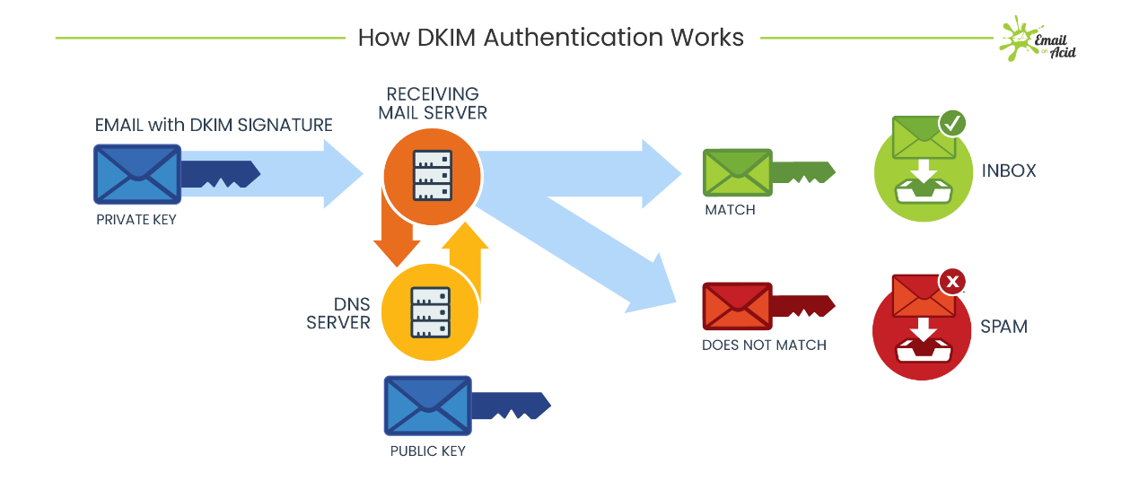

# Task 2: Understand the basic structure of an email header.

The current task is to understand the main components of an email header to prepare for identifying potential attacks. The following exercises will focus on analysing email headers.

**Open the file task1.txt from Canvas.**

task1.txt is one of the logs from SpamAssassin, which includes the complete details of a processed email. Let's extract some key components to analyse their purposes.

### 2.1 Basic email transmission information

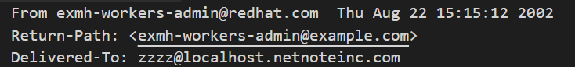

Figure 2 Basic email transmission information

1. **What is the purpose of the From field?**

*- displays the email sender's address, which is one of the most basic email header fields.*

*-From: exmh-workers-admin@redhat.com indicates that the email was sent by the address exmh-workers-admin@redhat.com. This field is typically used to show the recipient who the email is from.*

1. **What is the purpose of the Return-Path field?**

*- The Return-Path field, also known as the bounce path, specifies the address to which undeliverable mail should be returned. This field is typically set by the final receiving mail server after the mail transfer is complete, indicating where non-delivery reports (such as bounce messages) should be sent.*

*- Return-Path: exmh-workers-admin@example.com indicates that any delivery issues related to this email will be sent to exmh-workers-admin@example.com.*

1. **What is the purpose of the Delivered-To field?**

*- The Delivered-To field indicates the final delivery address of the email, specifying which mailbox the email ultimately reached. This field helps track the last-hop delivery information, especially when the email has been processed through forwarding or mailing list servers.*

*- Delivered-To: zzzz@localhost.netnoteinc.com shows that the email was delivered to the address zzzz@localhost.netnoteinc.com.header, Return-Path: exmh-workers-admin@example.com indicates that any delivery issues related to this email will be sent to exmh-workers-admin@example.com.*

### 2.2 Received Field

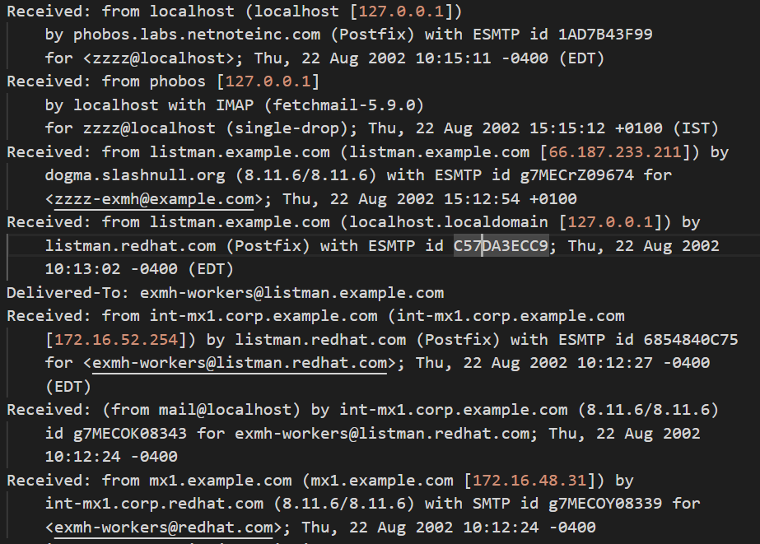

Figure 3 Basic email transmission information

1. **What is the purpose of the Received field?**

*Received Headers: This section records the path of the servers the email has passed through. The email has gone through multiple servers in succession, such as localhost.netnoteinc.com, listman.example.com, and mx1.example.com, each with a timestamp showing the various stages of the email's transmission.*

**Breakdown explanation**

Figure 4 Basic email transmission information

1. **What does the part "from listman.example.com (listman.example.com [66.187.233.211])" indicate about the origin of the email?**

*Answer: It indicates that the email was sent from the server named listman.example.com, which has an IP address of 66.187.233.211. Typically, the hostname and corresponding IP address are displayed in parentheses after DNS resolution.*

1. **Receiving Server: What does "by dogma.slashnull.org (8.11.6/8.11.6)" tell us about the server that received the email and the software it is running?**

*Answer: It shows that the email was received by the server named dogma.slashnull.org, and the version numbers 8.11.6/8.11.6 indicate the version of the Mail Transfer Agent (MTA) software (likely Sendmail) running on that server.*

1. **Transmission Protocol: What does "with ESMTP" signify regarding the protocol used for receiving the email?**

*Answer: It signifies that the email was received using the Extended Simple Mail Transfer Protocol (ESMTP), which is an extension of SMTP that supports more commands and features.*

1. **Transaction ID: How is the "id g7MECrZ09674" utilized in tracking the email?**

*Answer: The ID "g7MECrZ09674" is a unique identifier generated during the email's processing on the dogma.slashnull.org server, useful for tracking the status of the email and debugging transmission issues.*

1. **Receiving Recipient: What is the significance of "for zzzz-exmh@example.com" in the email header?**

*Answer: It specifies the final or intermediate mailbox address to which the email was sent.*

1. **Receiving Time: What information does "Thu, 22 Aug 2002 15:12:54 +0100" provide about the timing of the email's receipt?**

*Answer: It indicates the specific date and time when the email was received by the server, based on the GMT/UTC+1 time zone.*

***Question: what PGP is, what the web of trust is and what its purpose is?***



### 2.3 X-Mailer



Figure 5 X-Mailer

*Answer: This indicates that the email was created and sent using exmh version 2.5 and nmh-1.0.4.*

### 2.4 Email Content Type & Encoding

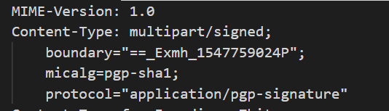

Figure 6 Email Content Type & Encoding

1. **What does "MIME-Version: 1.0" indicate about the email?**

*It indicates that the email follows the MIME 1.0 standard, allowing it to include non-text content, such as attachments.*

1. **What does "Content-Type: multipart/signed" signify regarding the email's content?**

*Answer: It signifies that the email content consists of multiple parts and includes a digital signature to verify the email's integrity.*

1. **What is the purpose of the digital signature protocol "application/pgp-signature"?**

*Answer: The application/pgp-signature protocol is used for PGP encryption signatures, ensuring the authenticity and security of the email content.*

***Question: what PGP is, what the web of trust is and what its purpose is?***



### 2.5 Email Body

To efficiently locate the body section in a MIME message, one can examine the **Content-Type header,** where the charset parameter may have various values, such as us-ascii or 'UTF-8,' as illustrated in Figure 7. Alternatively**, the original message can be highlighted**, as demonstrated in Figure 8.

Figure 7 Email Body

Figure 8 Email Body (come from record 0022.7241da4491c49b50c0470a3638ee35c4)

### 2.6 Digital Signature

At the end of the email, there is a PGP signature included, which is used to verify the sender's identity and ensure that the email content has not been altered during transmission.

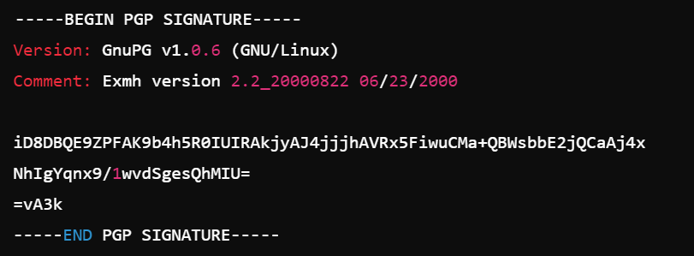

Figure 9 Digital Signature

### Practice1: Map out the journey of the email from sender to recipient

After reviewing the details of the email header in the MIME format, please answer the following three questions based on Figure 10.

Figure 10 Practice for mapping

**Q1: What is the IP address of the original sender?**

*203.0.113.1*

**Q2: Which servers (IP addresses) did the email pass through?**

*Mail.example.com and 10.0.0.1*

**Q3: What can you deduce about the timing of the email's journey?**

*It took 15 minutes to travel from first server to last*

### Practice2: Map out the journey of the email from sender to recipient

After reviewing the details of the email header in the MIME format, please answer the following three questions based on Figure 11.

Figure 11 Example of Email Data

Analysis Steps:

* Look for the Content-Type header and find the boundary identifier boundary="XYZ123".
* Use this boundary identifier to search within the email content and locate the first instance—XYZ123.
* Examine the Content-Type declaration of each part to determine the content type, such as text/plain or text/html.

**Q1: What is the content of the plain text version of the email?**

*Hello,*

*This is a sample email in plain text format.*

*Thank you!*

**Q2: How does the email client decide which part of the email to display?**

*It says text/html on the header*

**Note:** Including a plain text version alongside an HTML version offers several benefits

* Accessibility: Some users might have email clients that can only display plain text, or they may use screen readers that handle plain text better than HTML.
* Deliverability: Emails that include a plain text version alongside HTML are less likely to be flagged as spam by email servers, improving deliverability.
* Preference: Some users prefer the simplicity of plain text emails, either for ease of reading or due to bandwidth concerns.

### Practice3: Authentication Verification Task

Verifying the authentication mechanisms used in the email, such as SPF, DKIM, and DMARC records in the header. Have them evaluate whether the email could be considered authentic or spoofed based on these records. Answer the following five questions based on Figure 12.

Figure 12 Example of Email Data

**Q1: What does the email's SPF record indicate?**

*pass*

**Q2: What is the result of the DKIM verification?**

*pass*

**Q3: What does the DMARC record verification indicate?**

*pass*

**Q4: How can discrepancies in SPF and DKIM records affect email deliverability?**

*Failed SPF checks, reduced trust, failed DKIM checks, etc.*

**Q5: Why might an organization choose a DMARC policy of p=NONE?**

*Monitoring purposes, minimizing risk of false positives, phased rollout.*

# Task 2: Body Content Analysis Task

The current task is to analyse the body of the email to identify potential phishing attack tactics. This involves examining the language used, looking for suspicious links or requests, and assessing any unusual formatting or content that could indicate a phishing attempt. By understanding these tactics, we can better protect ourselves against malicious emails.

***



**Q1: What phishing emails are?**

*Phishing emails are fraudulent messages sent by attackers to trick recipients into providing sensitive information such as usernames, passwords, credit card numbers, or other personal details. These emails often impersonate legitimate organizations, services, or individuals to gain the recipient’s trust. The goal of phishing is typically to steal information, gain unauthorized access to accounts, or install malware on the recipient's device.*

**Q2: What the common tactics used in phishing email attacks**

*Spoofed sender addresses, urgency and fear, links to fake websites., malicious attachments, impersonation of authority, fake login prompts, social engineering, etc.*

### Practice4: Phishing Email Red Flags Identify

Please answer the questions based on the following fake phishing email:

|  |
| --- |
| Subject: **Urgent: Unauthorized Access Detected!**  From: **Security Team** [supp0rt@apple.com](mailto:supp0rt@apple.com)  Date: **October 5, 2024**  Dear Customer,  We detected unusual activity in your Apple account from an unrecognized device on October 4, 2024. For your protection, your account has been temporarily locked. You must verify your identity within 24 hours to avoid permanent suspension.  Please visit the link below to verify your account: [Verify My Account](http://apple-verify-login.com)  Thank you for taking immediate action.  Best Regards,  Apple Security Team |

**Q1: What are the issues with the sender's email address in this email? [Analyze the Sender’s Email Address]**

*Very fake email address. Says supp0rt instead of support.*

**Q2: How does the language used in the email influence the recipient's actions? [Evaluate the Urgency and Language Used]**

*Says urgent but email is sent a day after they’re “detected” unusual activities, which doesn’t make sense. Wants to make us feel panicked. Also time pressure.*

**Q3: What can you find out about the link included in the email? [Inspect the Link]**

*Non-specific link / disguised. High risk to a redirect link.*

**Q4: What can be said about the way the email addresses the recipient? [Look for Generic Greetings]**

*Lack of personalization, also impersonal tone. Usually big companies will know either your name, username, or ip address. So the way the email is sent, (only wit “Dear Customer” raises red flag)*

**Q4: Does this email request any personal information directly? [Request for Personal Information]**

*Indirectly, yes. The link would probably send the users to fake website that mimics Apple’s login page and steal their information there.*